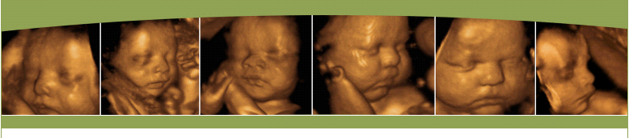

WHA Capital Area Ob/Gyn
3D/4D Ultrasounds

Check on me: 7-14 weeks $50.00
2D, 3D/4D glimpse to see baby move and hear heartbeat
10 minutes

Gender Reveal: 15-25 weeks $80.00
Gender in 2D, 3D/4D glimpse, CD, email and 2 B&W pictures
15 minutes

See who I look like: 26-32 weeks $150.00
2D/3D/4D CD, email and 5 B&W pictures and mini videos
30 minutes

Please call 919.781.7450 to schedule.
Raleigh-Every Tuesday from 3:30 pm-4:00 pm
Cary-Every Wednesday from 3:30 pm-4:00 pm

